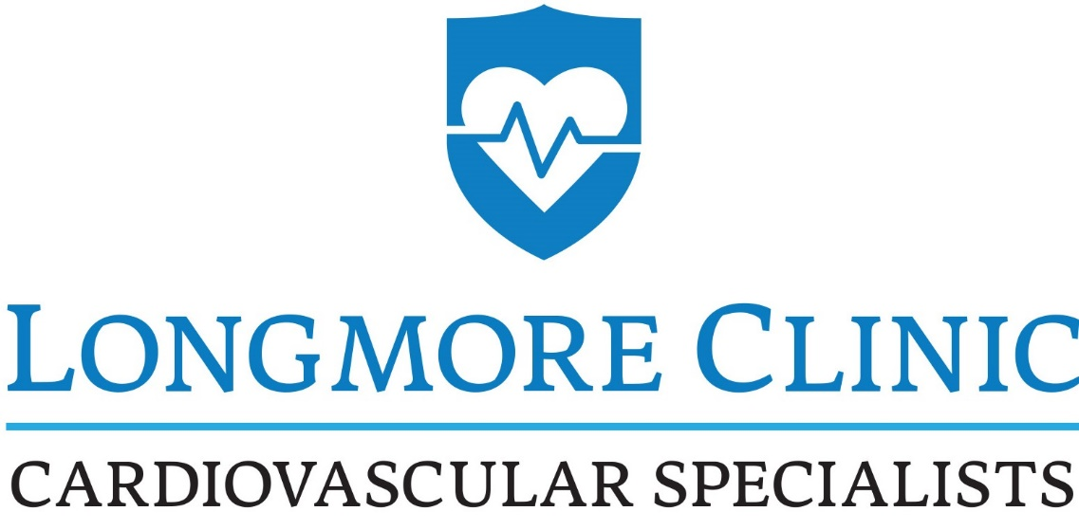
1515 E Clark Street
Pocatello, ID 83201
(P) 208-233-2273 (F) 208-233-2490

Fax Cover Sheet
FROM: Sender’s name: Kathy M. - Medical Records Specialist

Doctor: Dr. Lance Longmore______________

Fax number: 208-233-2490 (MAIN Fax#)

Phone number: 208-233-2273 ________
Message:

Please send any faxes to our regular fax #: 208-233-2490.

Confidentiality Notice: The enclosed documents are the property of Longmore Clinic, and are confidential and legally privileged. They may contain medical information protected by Federal, and Idaho state law. They are for your agency’s use only. Any re-disclosure of this information by the recipient is strictly prohibited.

